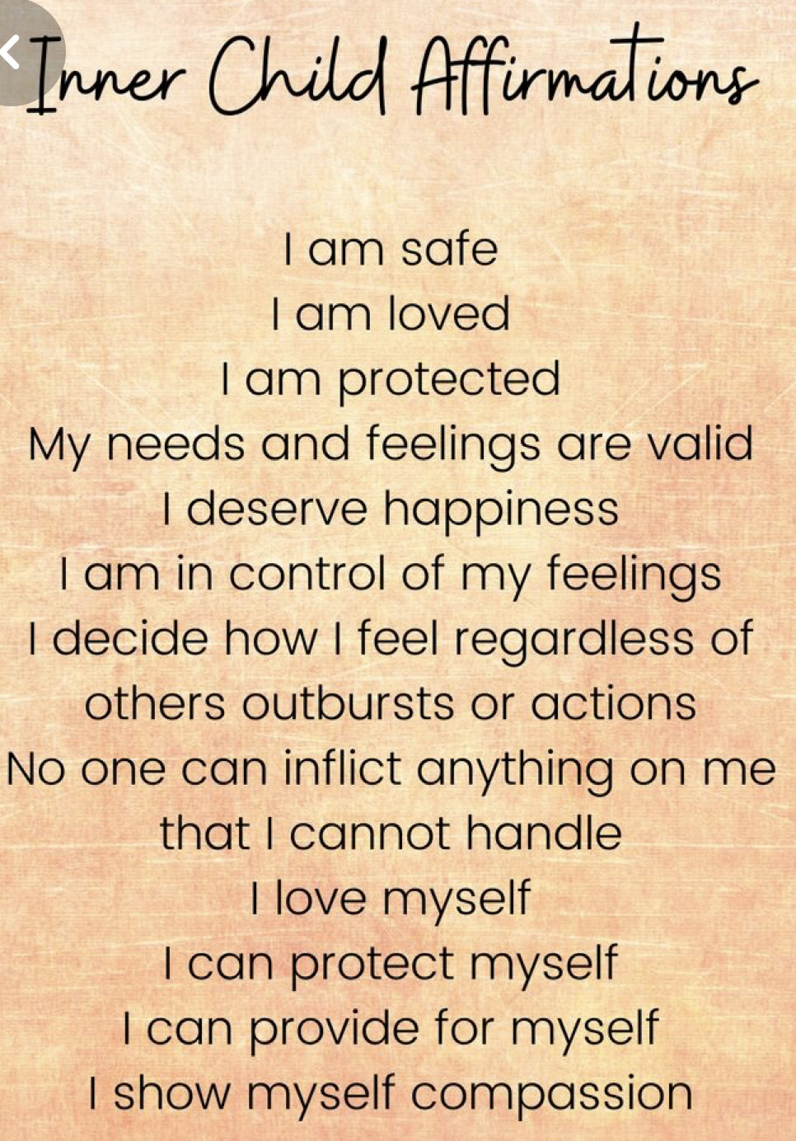



**BURNOUT PREVENTION**

30 Min of Self care Y/N No Hyper-focus Y/N

Me time Y/N Delegating & Using my Support Y/N

PRIORITIZING MY HEALTH

Took All Meds Y/N Verified if Refills Needed Y/N SCHEDULED: Medical Appt Y/N Psych Testing Y/N

Therapy Y/N Labs/Referrals Y/N

DAILY SELF THERAPY:

EMDR: [Blaze Clicker](https://youtu.be/eLAgmT_R8UA), [Tone Green Dot](https://youtu.be/DALbwI7m1vM), [Pulse](https://youtu.be/CJQc7arNFGc)

Meditations:[ ] [Self Worth](https://theadultchair.com/portfolio_page/a-guided-meditation-on-worthiness/) [ ] [Grounding Meditation](https://theadultchair.com/portfolio_page/grounding-meditation/) [ ] [Boundaries](https://theadultchair.com/portfolio_page/a-guided-meditation-for-setting-boundaries/) [ ][Inner Child](https://theadultchair.com/portfolio_page/a-guided-meditation-to-connect-with-your-inner-child/) [ ] [Shame](https://theadultchair.com/portfolio_page/a-guided-meditation-and-exercise-for-releasing-shame/) [ ] [-Programming](https://theadultchair.com/portfolio_page/inner-child-meditation-for-codependency-lack-of-self-love-and-negative-programming/)[ ] [Self Love](https://theadultchair.com/portfolio_page/5-minute-self-love-meditation/)

Journal Prompts [ ] [Emotion Processing](https://morrisonclinic.com/wp-content/uploads/2021/06/Emotion-wheel-and-processing.pdf) [ ] [Conflict](https://morrisonclinic.com/wp-content/uploads/2021/06/Fear-Story-and-Conflict-Journal-Prompts-4.13.pdf) [ ][Self Love](https://morrisonclinic.com/wp-content/uploads/2021/06/Daily-Self-love-journal-.pdf) [ ][Daily Reflection](https://morrisonclinic.com/wp-content/uploads/2021/06/10-min-daily-reflection-.pdf) [ ] [Self Therapy](https://morrisonclinic.com/wp-content/uploads/2021/06/self-therapy-journal-prompt.pdf) [ ] [Relationship](https://morrisonclinic.com/wp-content/uploads/2021/06/Early-relationship-assessment-Conscious-dating-and-friendships-6.27.21.pdf)

REASONABLE PARENTING LOAD

School Y/N Emotions Y/N Activities Y/N

Minimum of Weekly Evening Parenting Break Y/N

REASONABLE WORK LOAD

Daily Work Volume Y/N

Daily Emotional Toll of Work Y/N

Area 3 Y/N

Area 4Y/N

INTENTIONAL CONNECTION WITH OTHERS

Name: Y/N

Name Y/N

Name Y/N

MEDITATIONS:

FOCUS:

SELF CARE

TODAY I CHOSE TO FOCUS ON ME

Your power comes from NOT ENGAGING IN UNHELPFUL CONVERSATIONS you choose what behaviors you accept which teaches others how to treat you. You are in control. noBODY bullies, badgers, or upsets you if engaging is your choice.

DATE:

SCREEN FOR AUTOMATIC FRAGMENTED SELF RESPONSES

Y/N FIGHT BEHAVIORS: Lawyer-Mode, Angry, Justify, Frustrated, Defensive, Reactive, Heart Pounds, Raise voice, Punch, stomp, hurt others/self

Y/N FLIGHT BEHAVIORS: Afraid, Restless, Uneasy, Heart Pounding, Gut or Chest Anxiety, Feel Trapped, Hyper-vigilant, Seek Reassurance, Panic, Too Busy, Perfectionistic

Y/N FREEZE BEHAVIORS: 😴, Numb, Isolate,Tired, Difficulty Processing and Making a Decision, Sense of Dread

Avoidant Behavior: Procrastinating, ⬆️ Screen Time, Obsessing about something unrelated, Hyper Focusing, Give Up, Not confronting a person or problem. Y/N ATTACH BEHAVIORS: Sad, Desperate to Connect, Lonely, Unloved, Ugly, Worthless, Excited by Yo-Yo Pull

Y/N SUMBIT BEHAVIORS: Ashamed, Guilty, I’m doing something wrong, You will never be ok

COPING WITH INSULTS TO WELL BEING BY GROUNDING AND FOCUSING ON SELF LOVE AND SELF WORTH

BE STILL:Gave permission to be exactly as I am Y/N Didn’t complicate and if felt confused grounded myself Y/N Trusted my gut & feelings Y/N

BE SECURE: I’m worthy Y/N, There’s nothing wrong with me Y/N, If sensitive did self worth meditation Y/N I always adapt amazingly well. Y/N ONCE YOU HAVE GROUNDED TO A FEELING OF SAFETY: dive further into recognizing unhealthy and unsafe behaviors to better identity what is happening and to learn what else to look for

RECOGNIZE UNSAFE PEOPLE AND CREATE DISTANCE:

Is anyone: Seeding Doubt Y/N “Joking” with intent to insult, mislead, or evoke an emotion? Y/N Being Critical/Judgmental?: Y/N [Using sarcasm or humor to disguise anger](https://www.psychologytoday.com/us/blog/think-well/201206/think-sarcasm-is-funny-think-again)? Y/N [Creating scenarios to satisfy their need to feel superior?](https://morrisonclinic.com/wp-content/uploads/2021/06/Chaos-and-Narcissists-How-Disorder-Favors-Narcissists-Exploring-your-mind.pdf) Y/N [Inconsistently pursuing you?](https://morrisonclinic.com/wp-content/uploads/2021/06/Love-Bombing-From-A-Narcissist-or-Not.pdf) Y/N [Love bombing](https://www.healthline.com/health/love-bombing#disrespecting-boundaries) or [hoovering](https://www.healthline.com/health/hoovering) or is it [hard to tell intentions](https://www.healthline.com/health/love-bombing#disrespecting-boundaries)? Y/N Acting as if nothing is wrong after a recent conflict? Y/N Not taking your feelings into account? Y/N

Is anyone triggering feelings of : Warning in your gut? Y/N [Abuse](https://morrisonclinic.com/wp-content/uploads/2021/06/15-Disturbing-Forms-of-Verbal-Abuse-in-Relationships-Psychology-Today.pdf) Y/N [Invalidation?](https://morrisonclinic.com/wp-content/uploads/2021/06/Gaslighting-Phrases-that-Make-You-Question-Your-Sanity-Exploring-your-mind.pdf) Y/N Emotional blackmail: [Confusion, false or obligatory guilt ?](https://positivepsychology.com/emotional-blackmail/) Y/N Hurt Y/N Shame Y/N Rejection Y/N

DISARMING INCONGRUENT, UNSAFE PEOPLE:

Remembered NOTHING an abuser does or says is authentic. Y/N

Today when navigating unsafe people I: Evaded attempts to dig for infoY/N Kept it superficial Y/N Kept my power, nothing derailed me Y/N Took my attention away from chaos. Y/N Took nothing personally? Y/N I kept necessary engagement incredibly brief and direct Y/N Set boundaries using Our, My Statement? Y/N Played the stupid card to disarm sarcasm and conflict bait. Y/N

Recent disarming scenarios:

Method I used to disarm:

I recently disarmed ____________and if I had to guess they will push back or vindicate by:

**MORRISON CLINIC TRAUMA INFORMED DAILY ACCOUNTABILITY JOURNAL**